**SCREENSHOTS**

1. **EC2 ( Amazon Elastic Computer Cloud )**

**1.Choosing AMI**

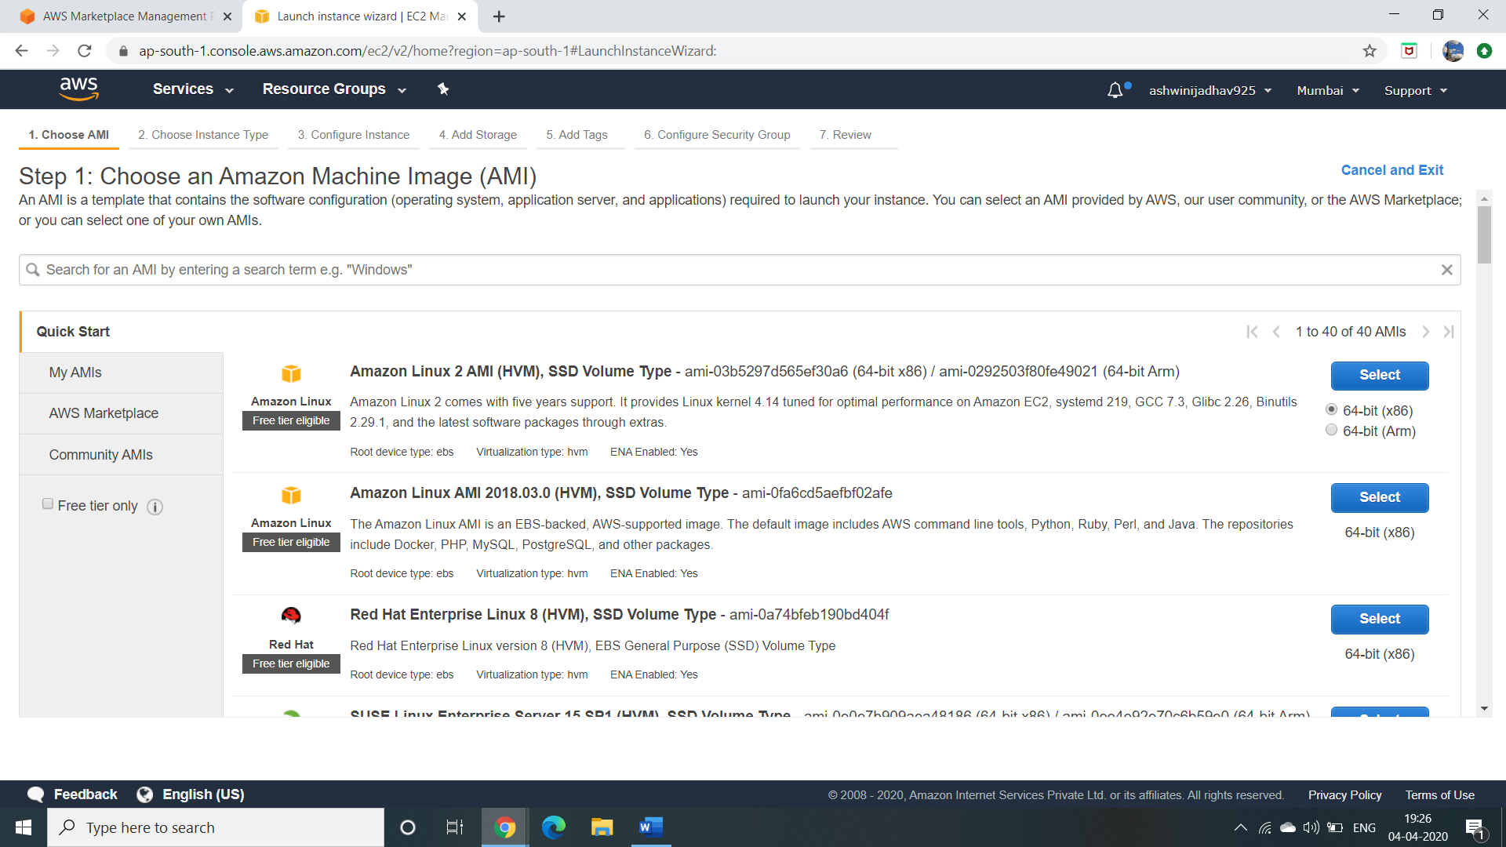

**2.Choosing Instance Type**

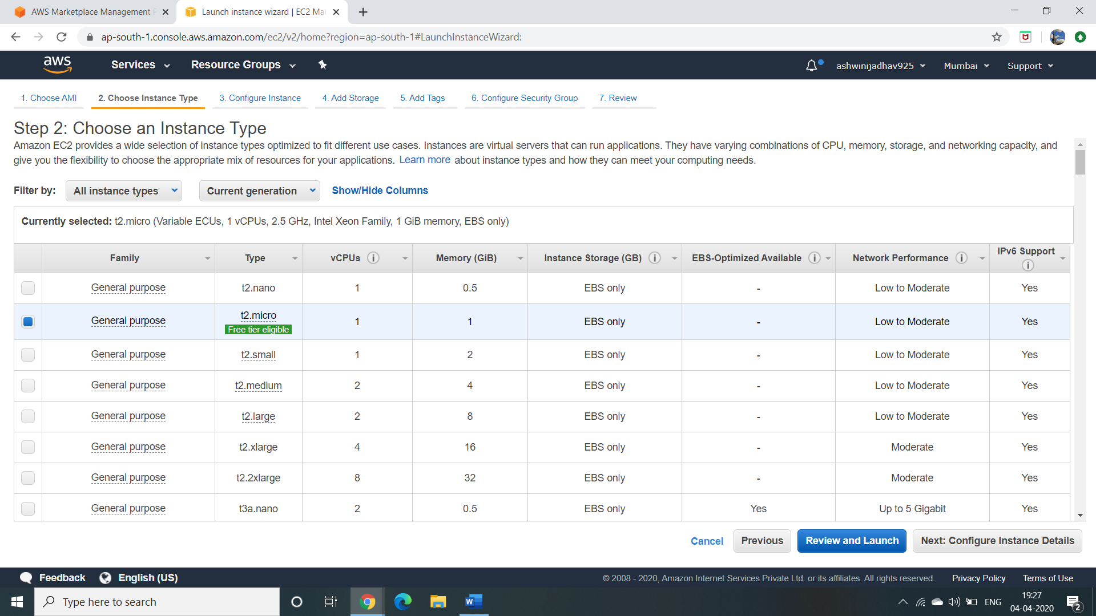

**3:Add Storage**

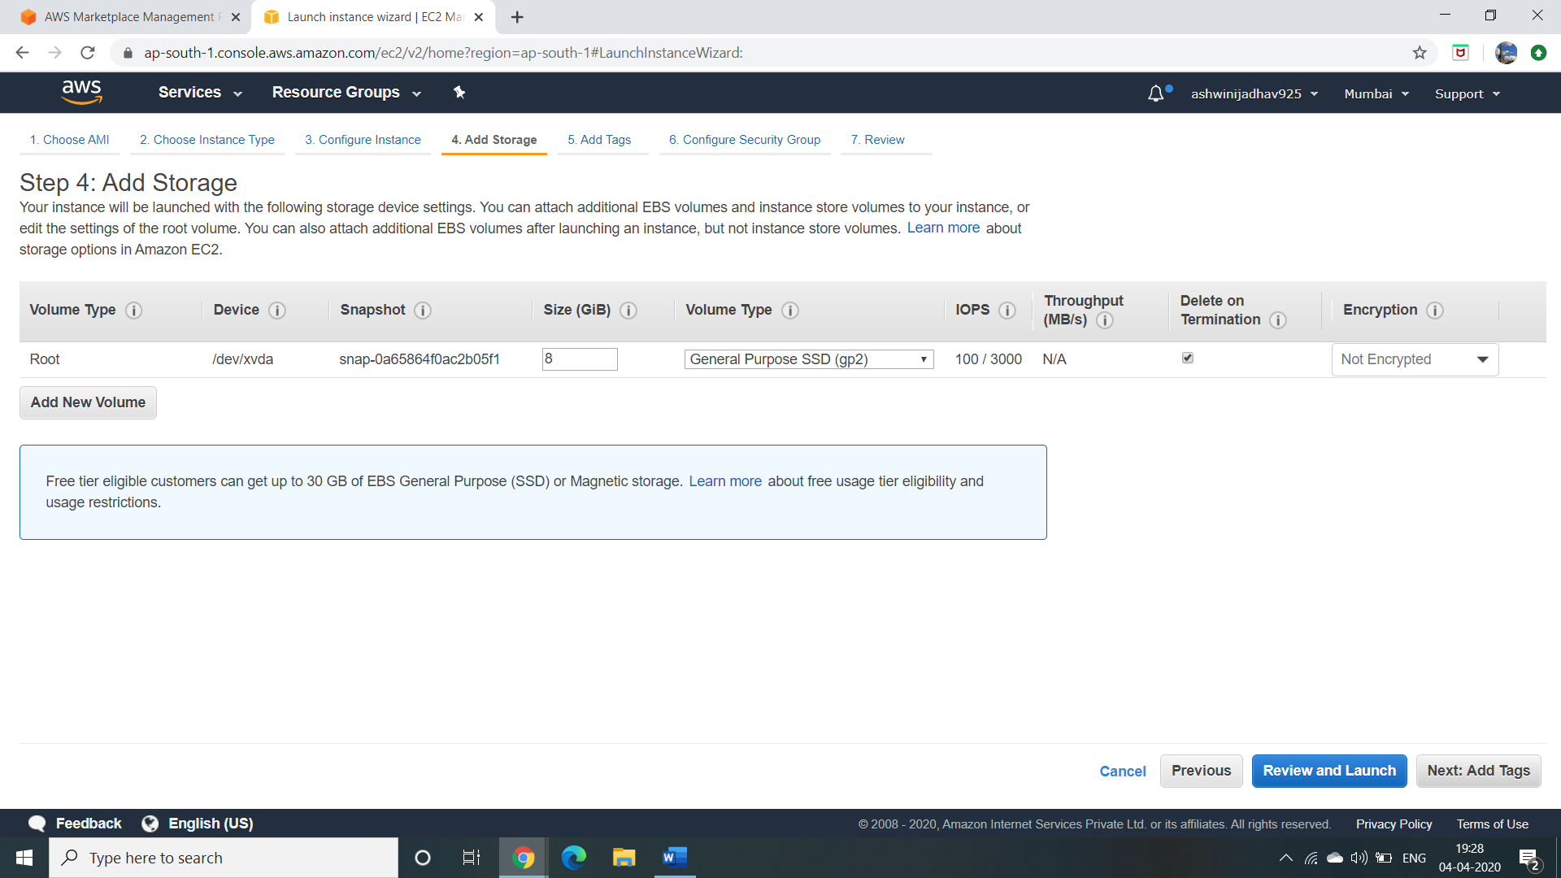

.

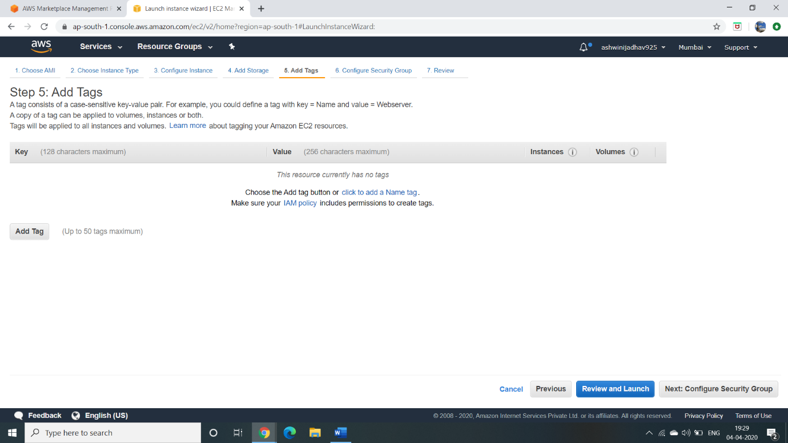

**4: Configure Security Group**

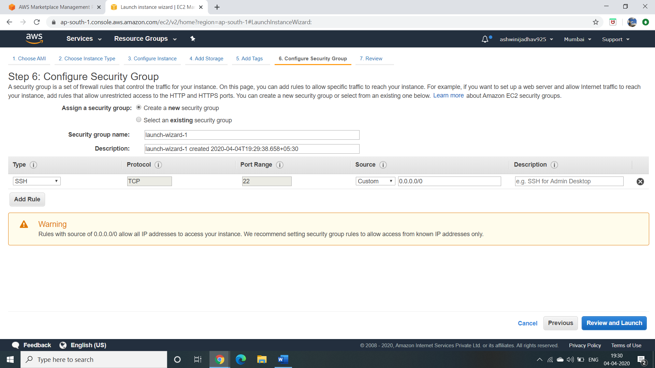

**5: Download Key Pair**

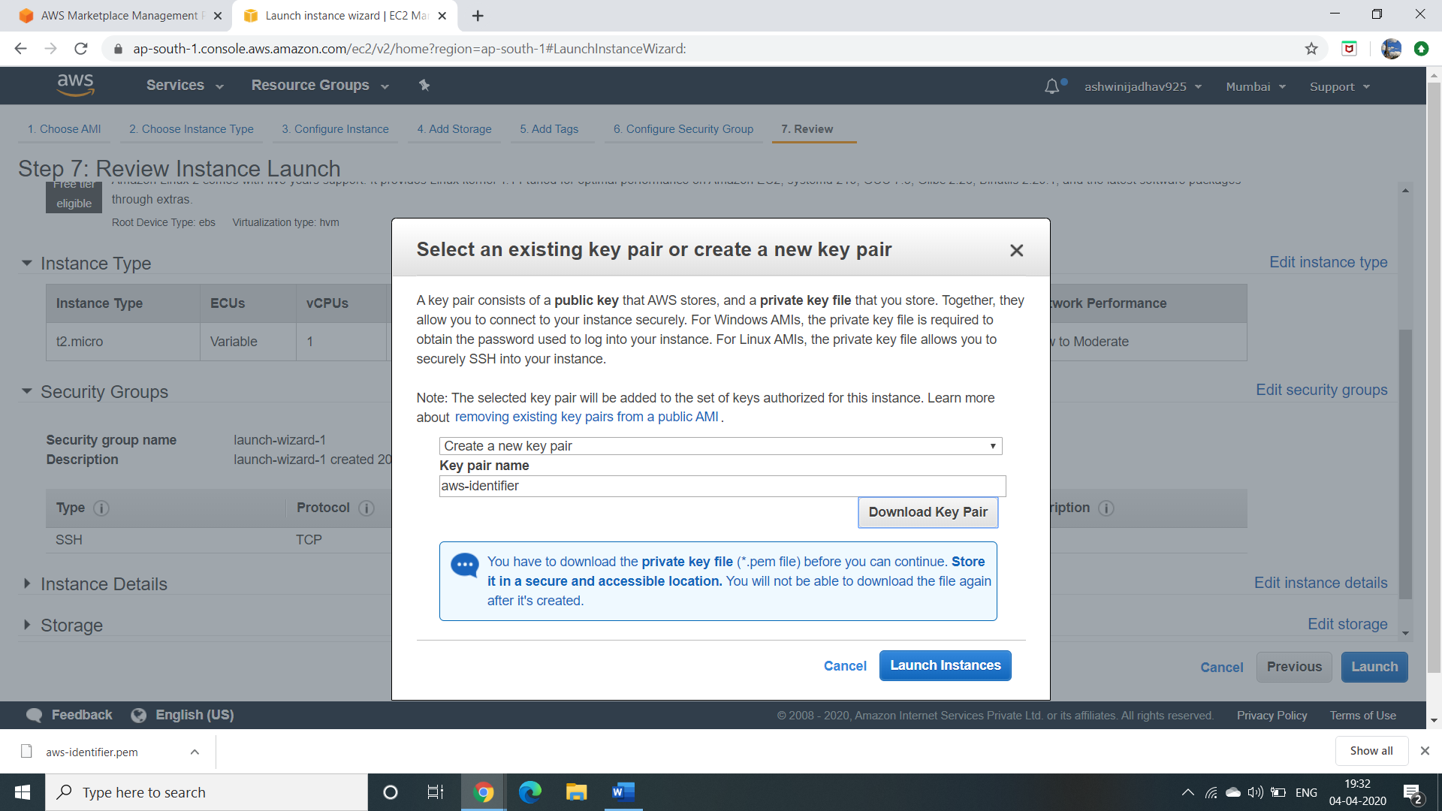

**6: puTTYgen conversion from pem to ppk**

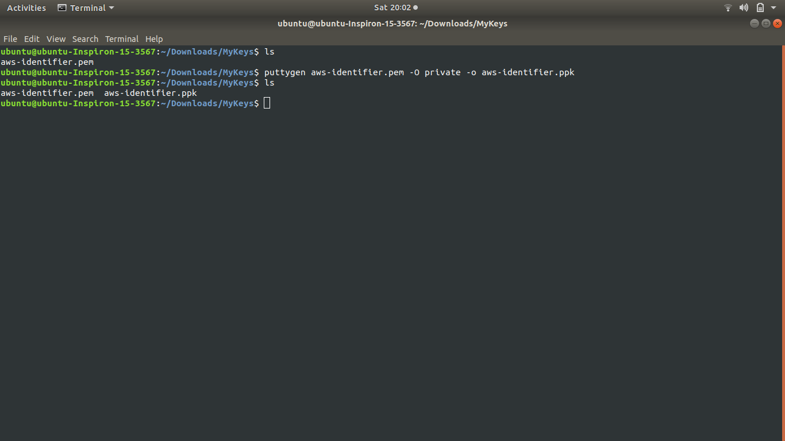

**7: Logged in EC2 terminal access** 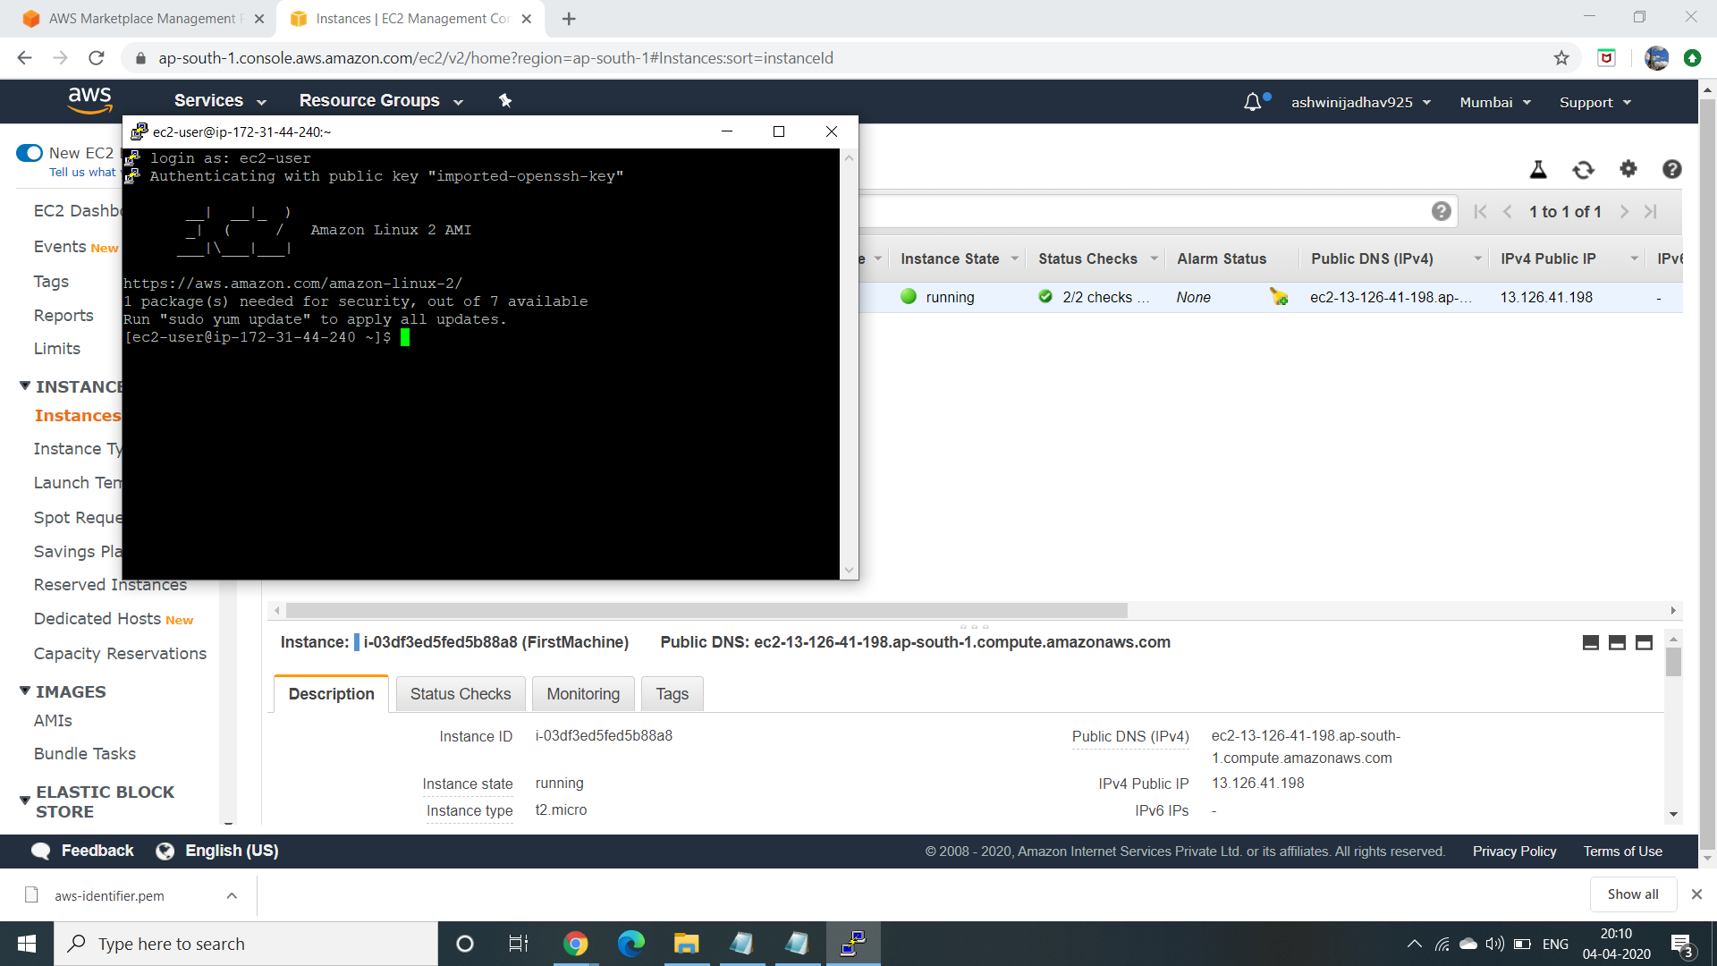

1. **S3 ( Amazon Simple Storage Service )**

**1: Creating a Bucket**

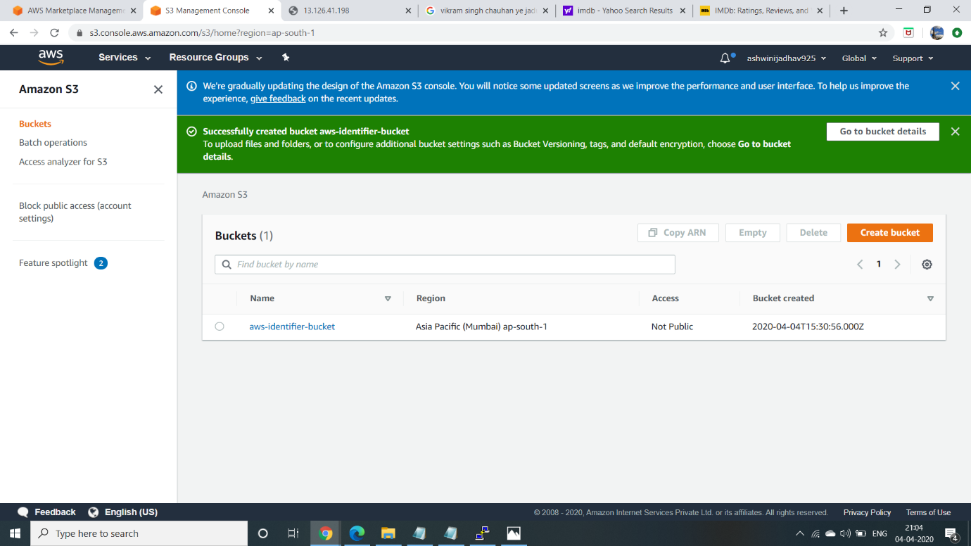

**2: Uploading an Object**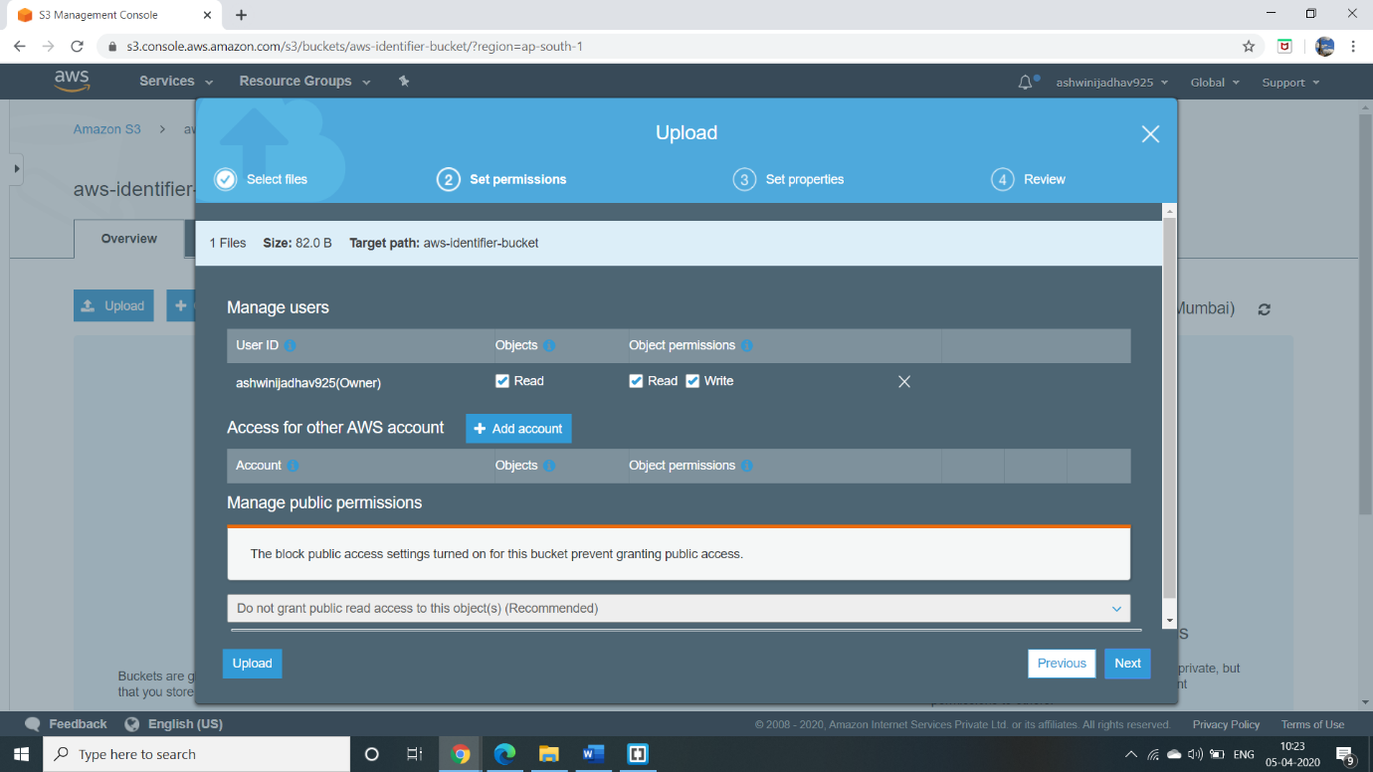

**3: Enabling Static Website**

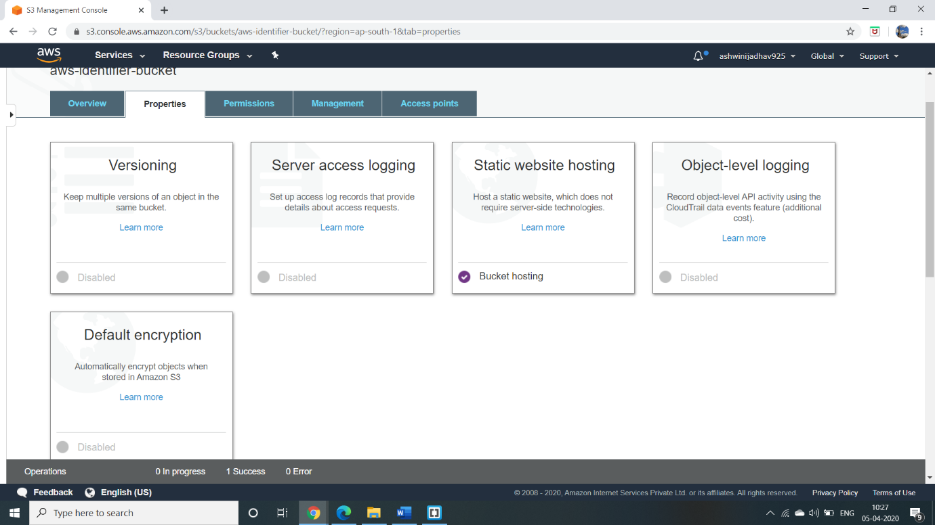

**4: Make Object Public**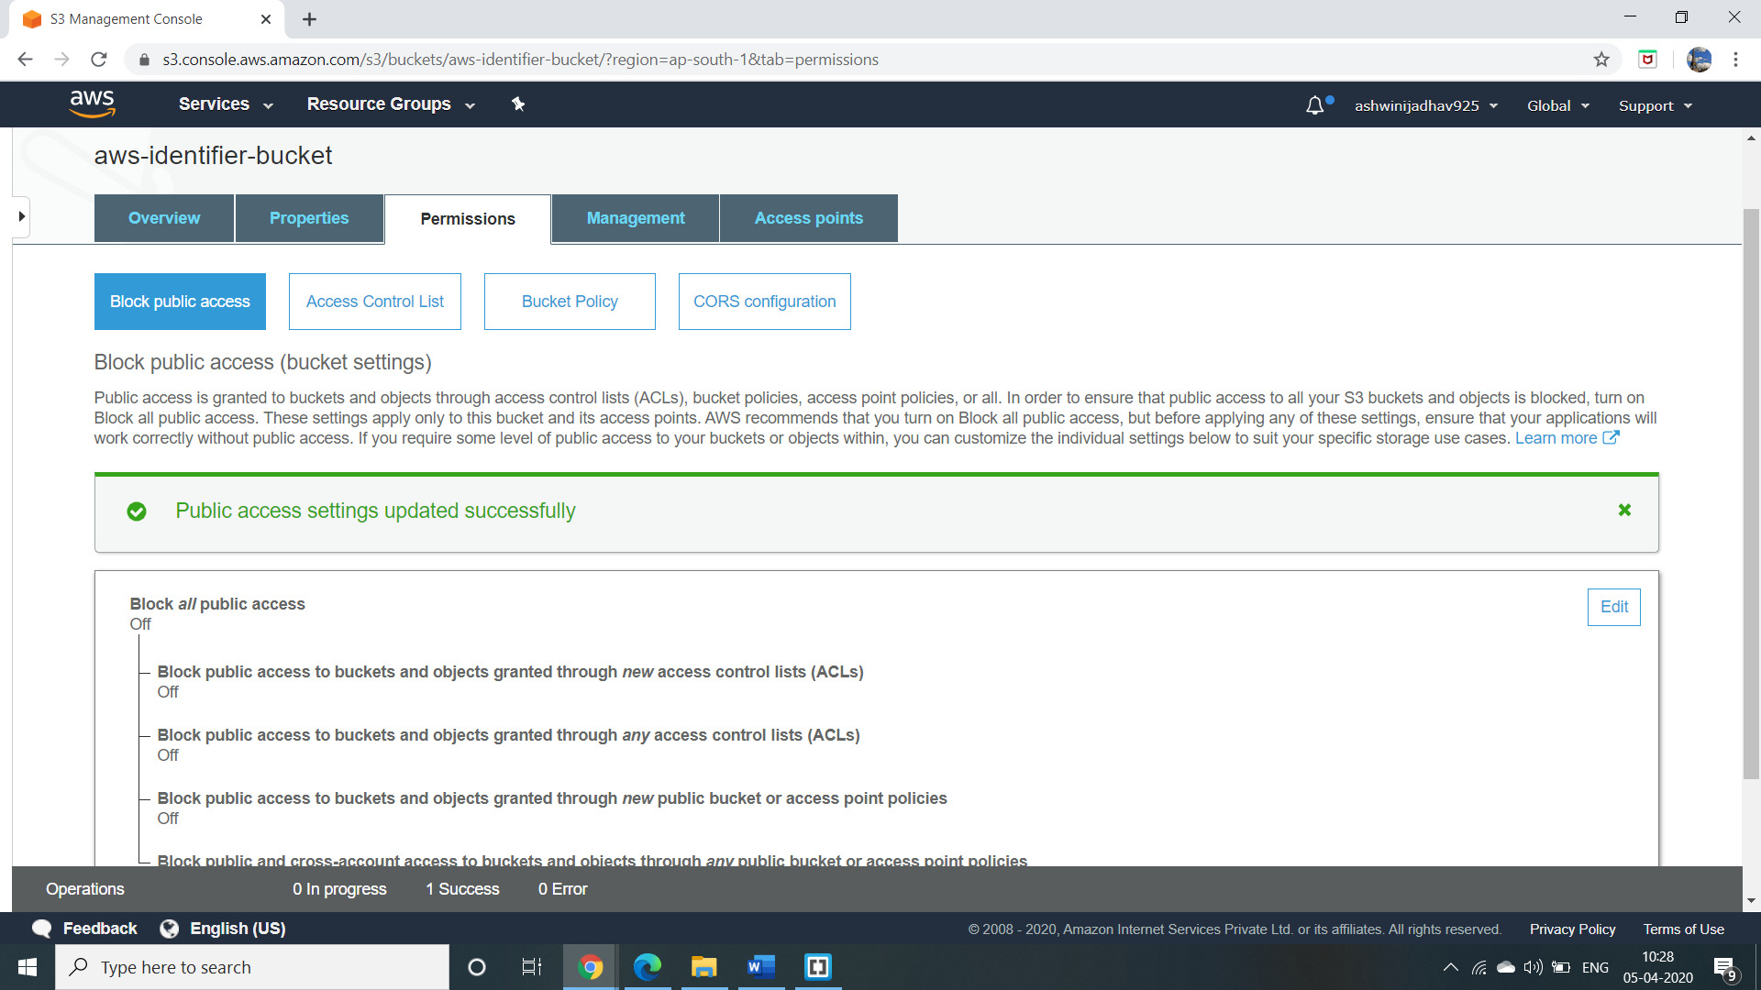

**5: Checking S3 link on browser**

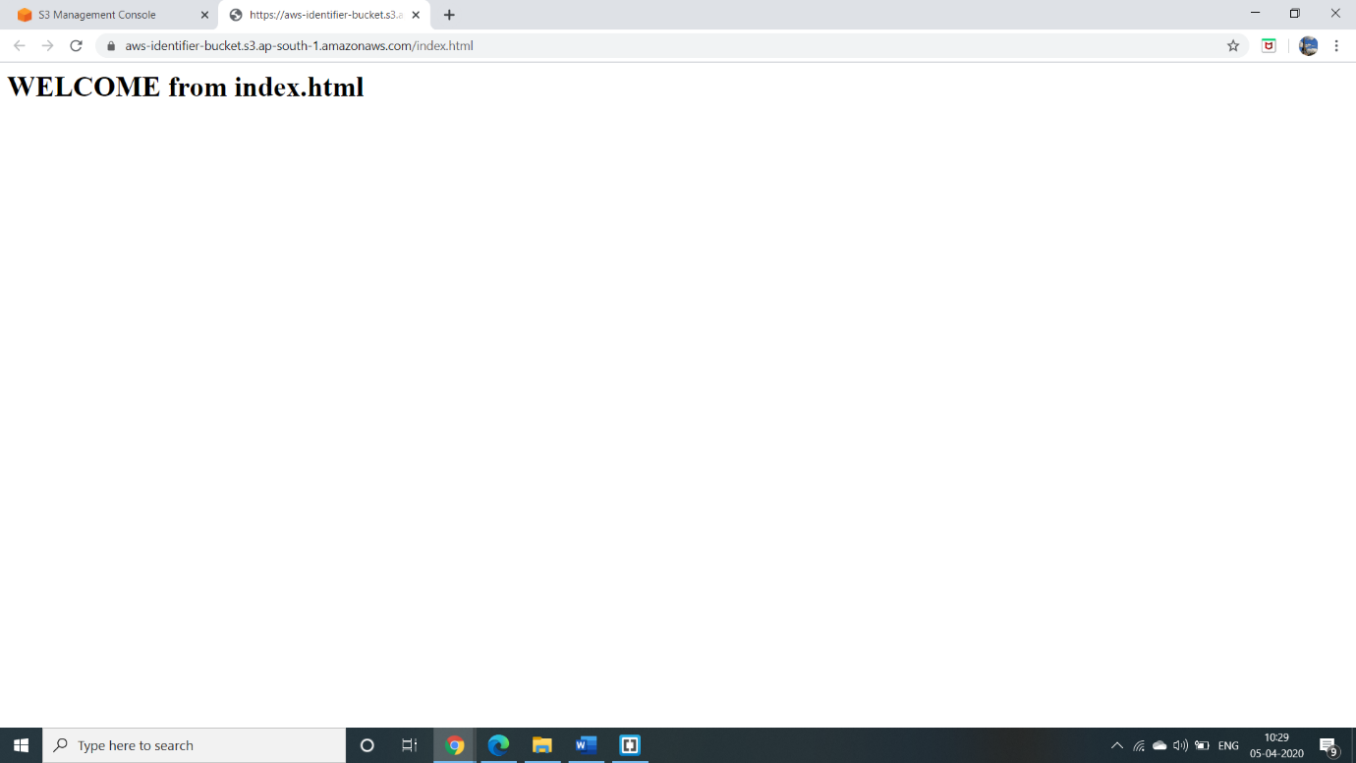

1. **Amazon Rekognition**

**1: Face Analysis**

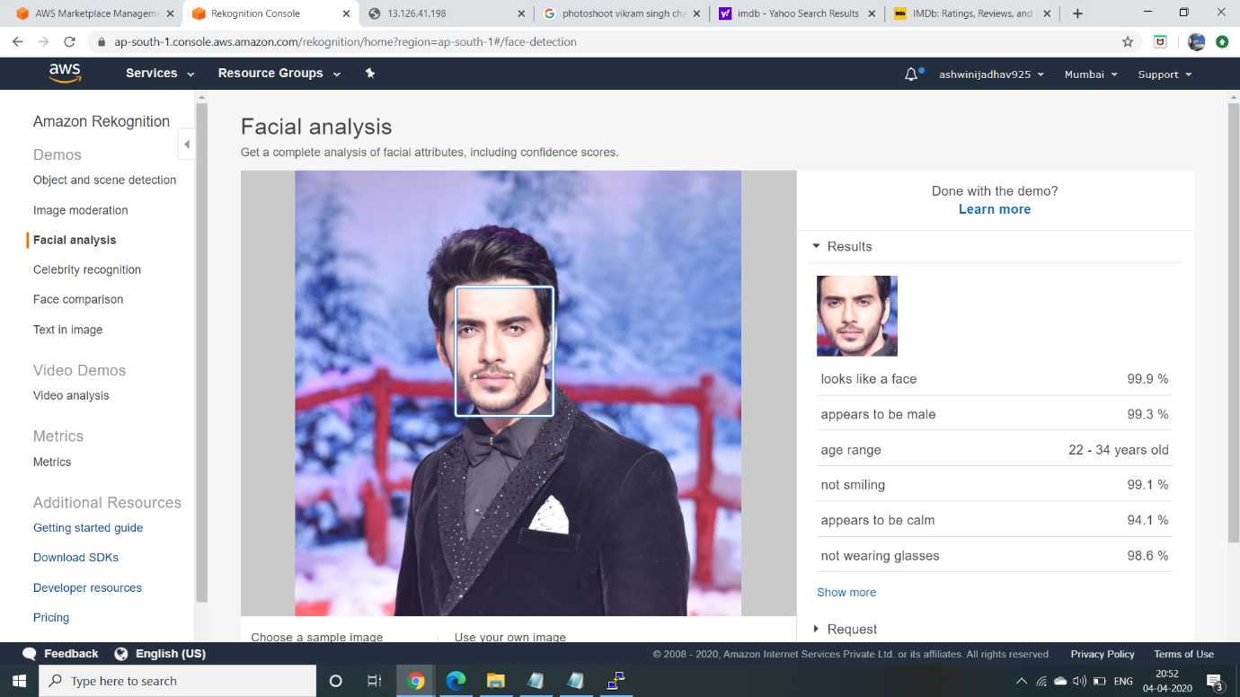

**2: Face Comparison**

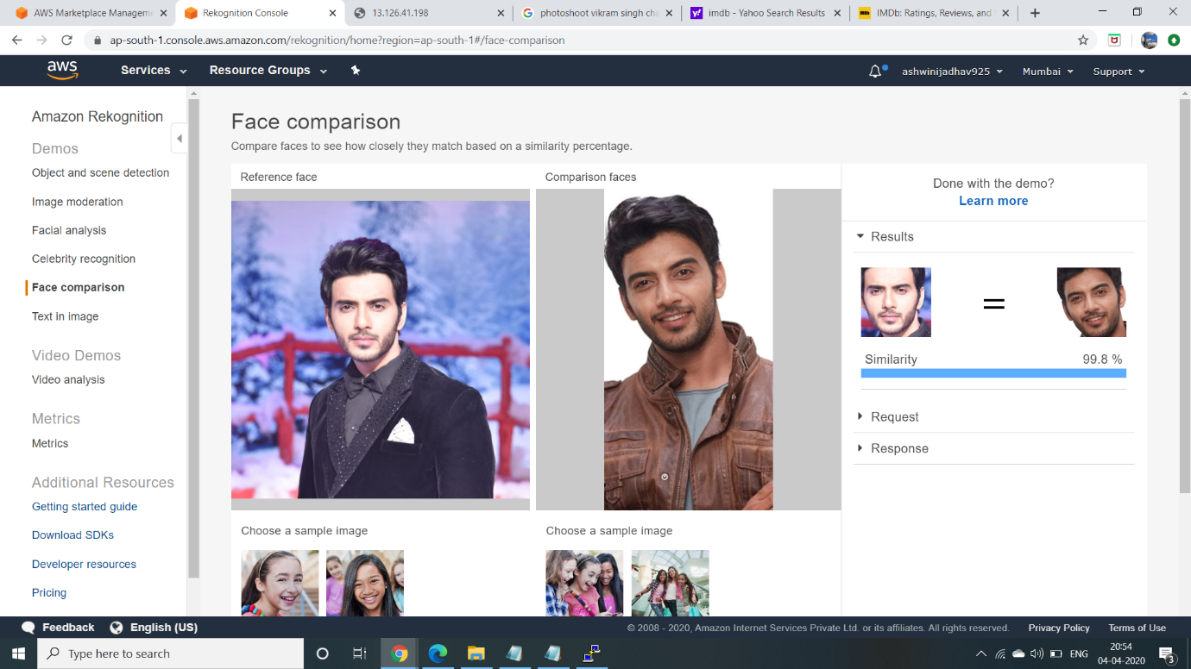

**3: Celebrity Recognition**

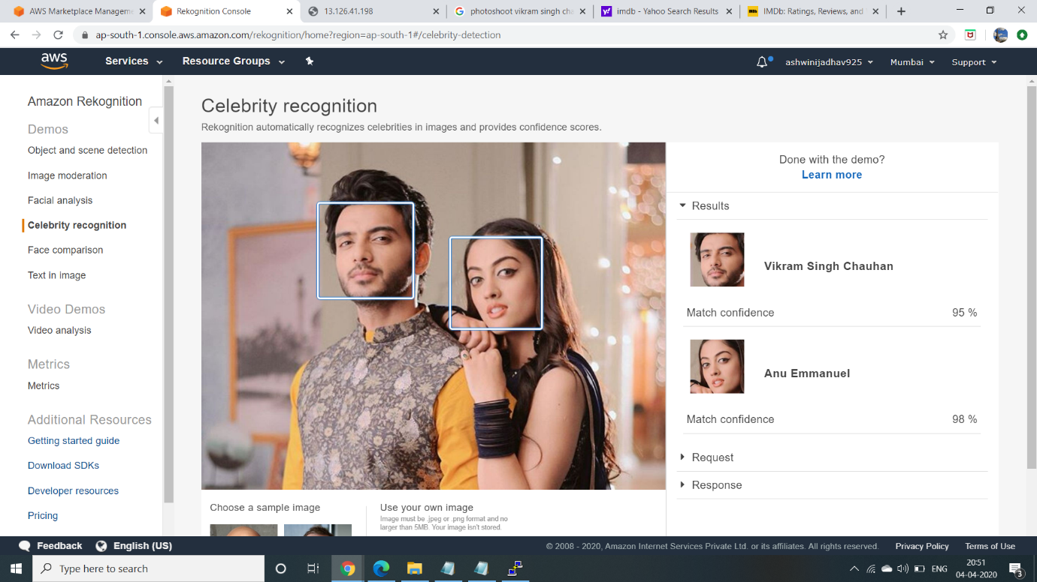

**4: Text in Image**

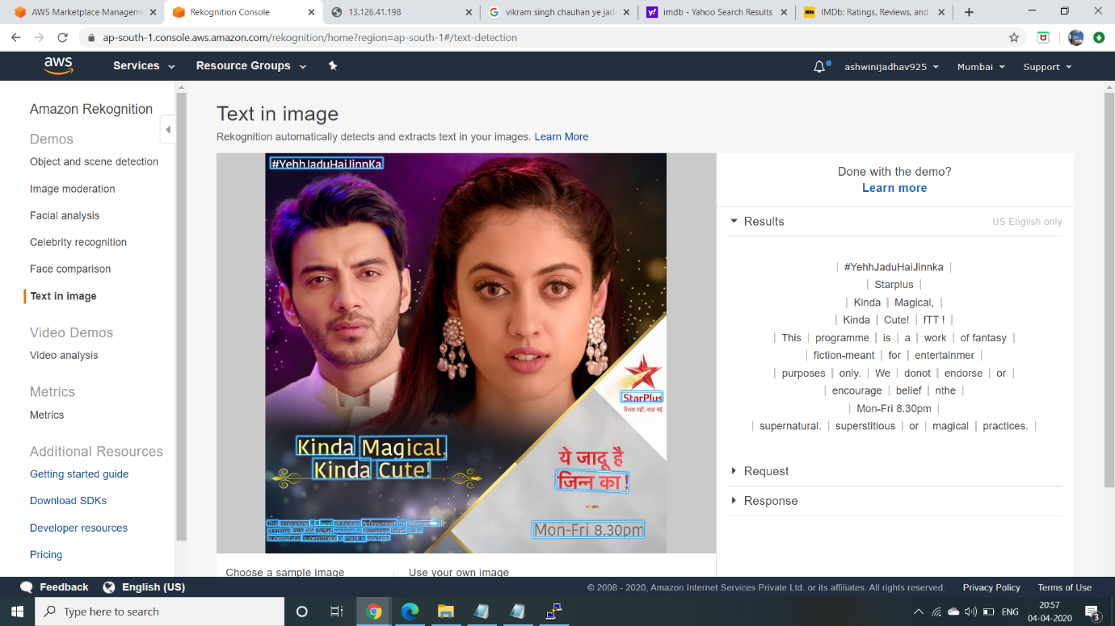

1. **EC2 and S3**

**1: Installing AWS SDK**

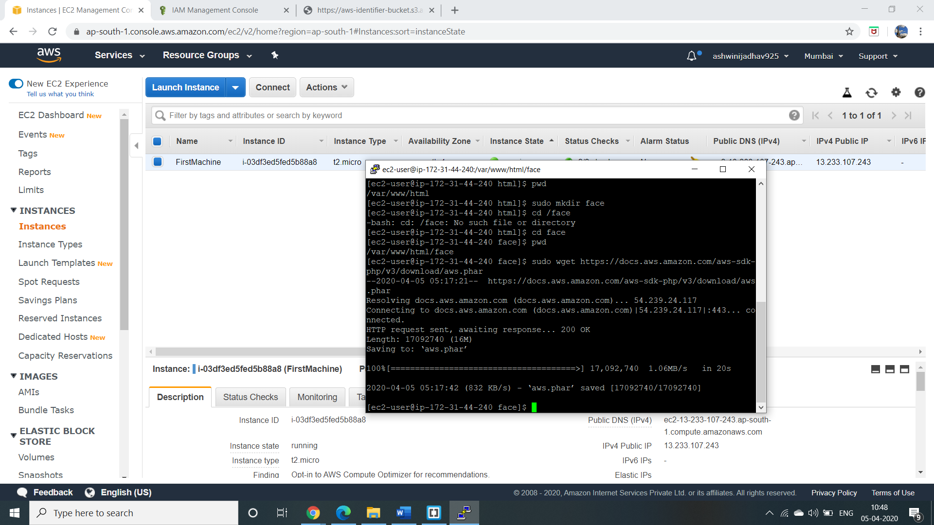

**2: Installing PHP**

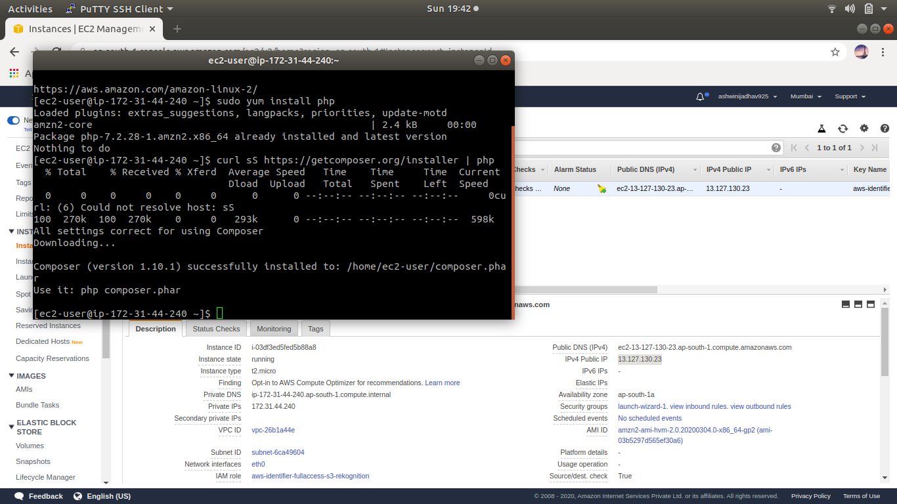

**3:PHP file index.php Content**

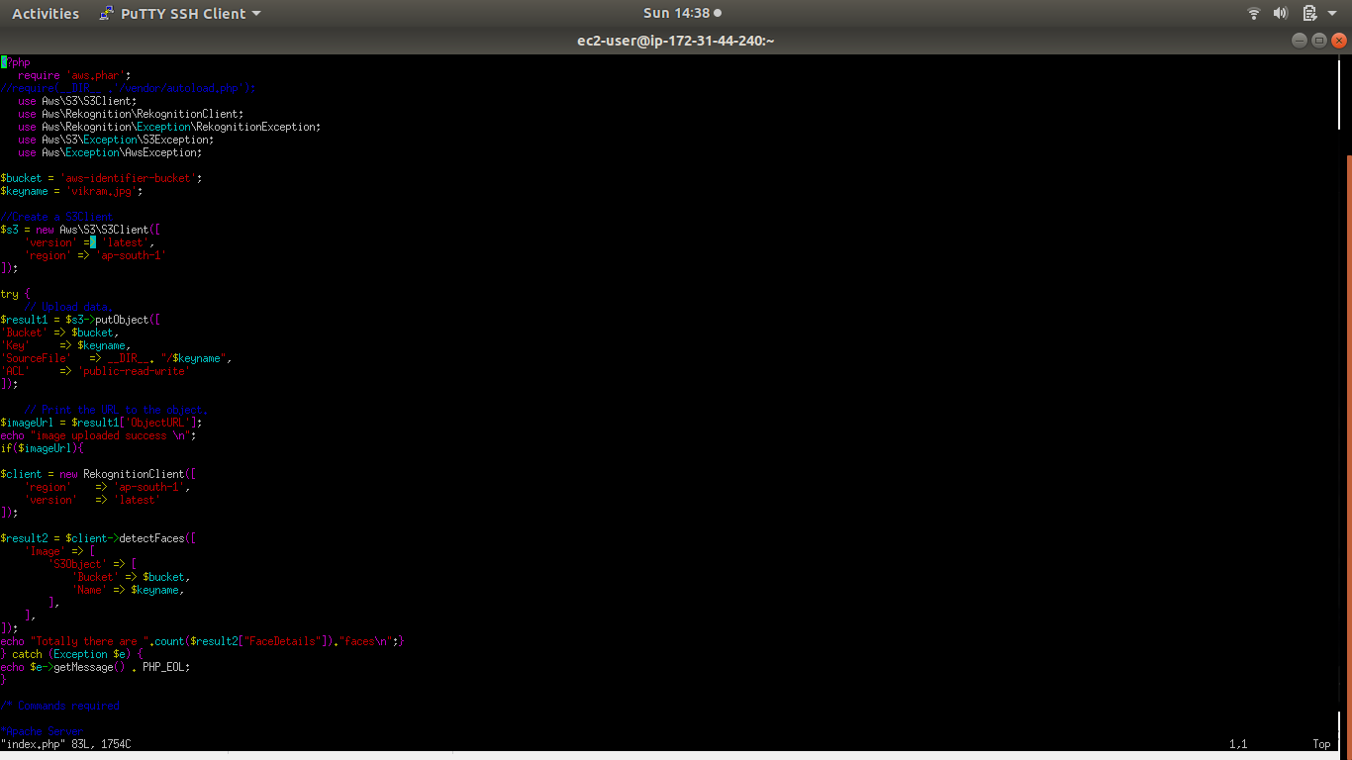

**4: Upload success**

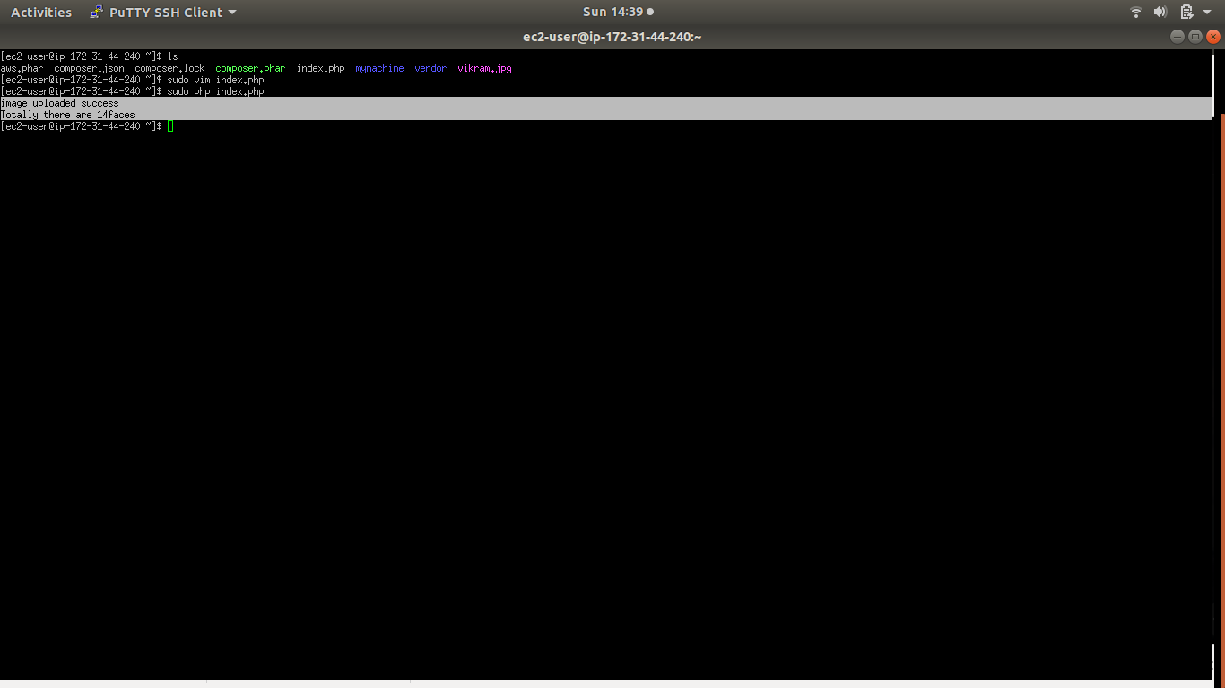

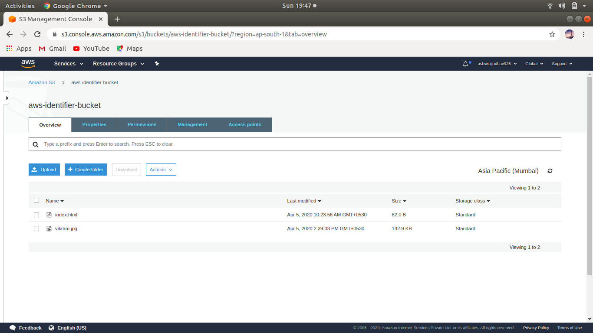

1. **EC2 and rekognition**

**1: Face Detect success**



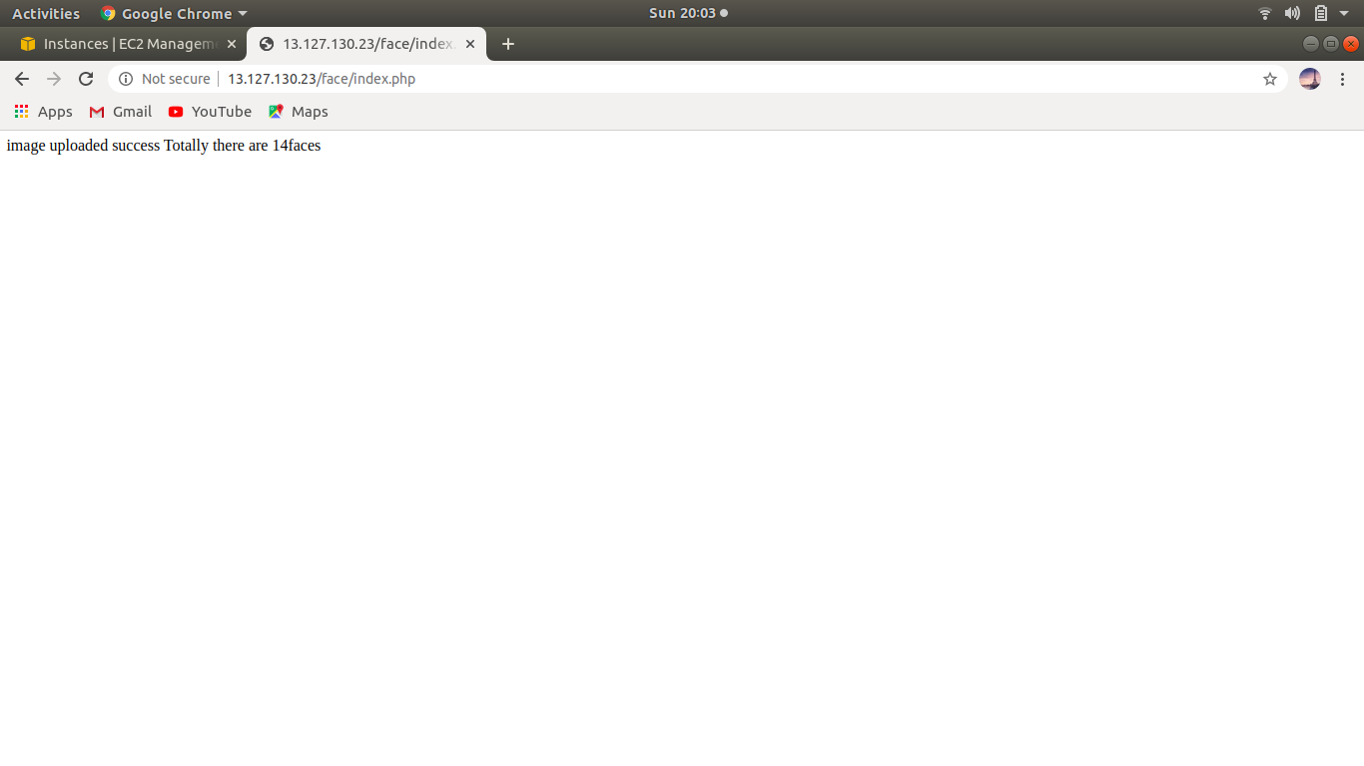

1. **Dashboard**

**1:AWS login screen**

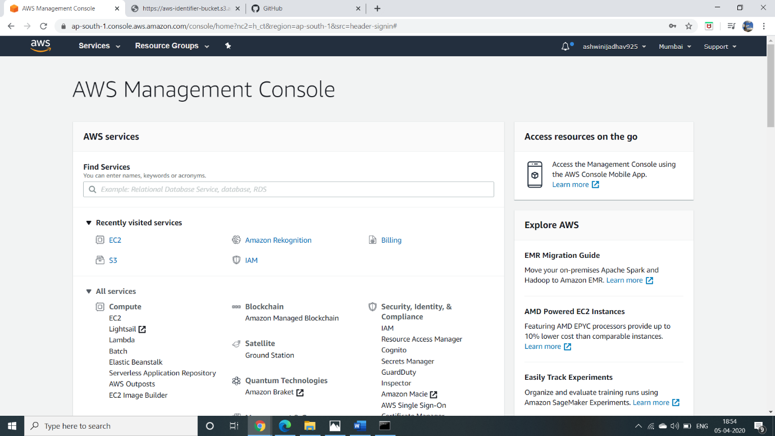

**2:EC2 Dashboard**

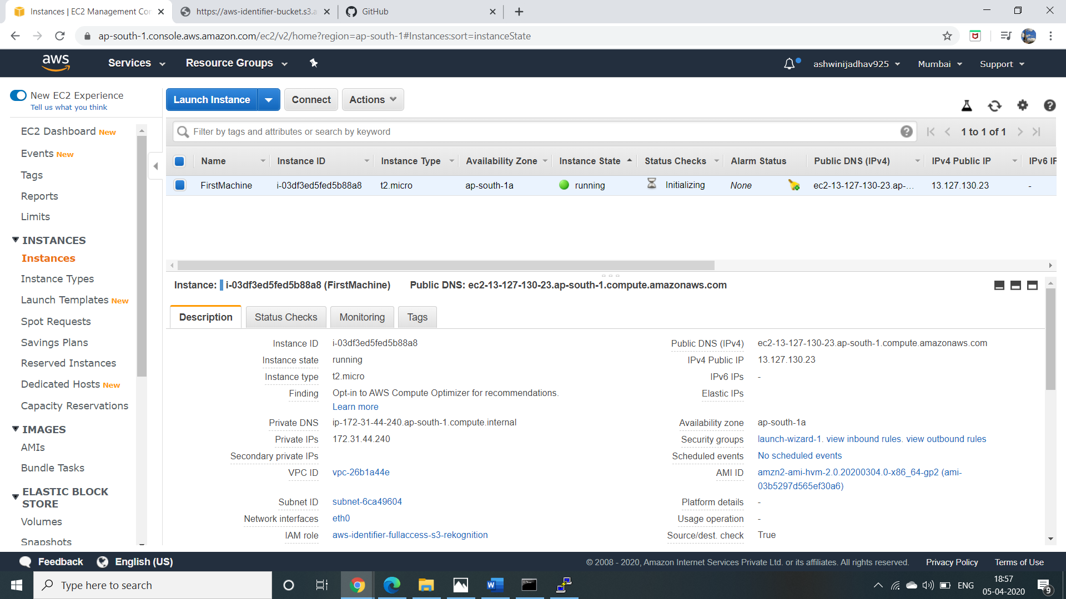

**3: S3 Dashboard**

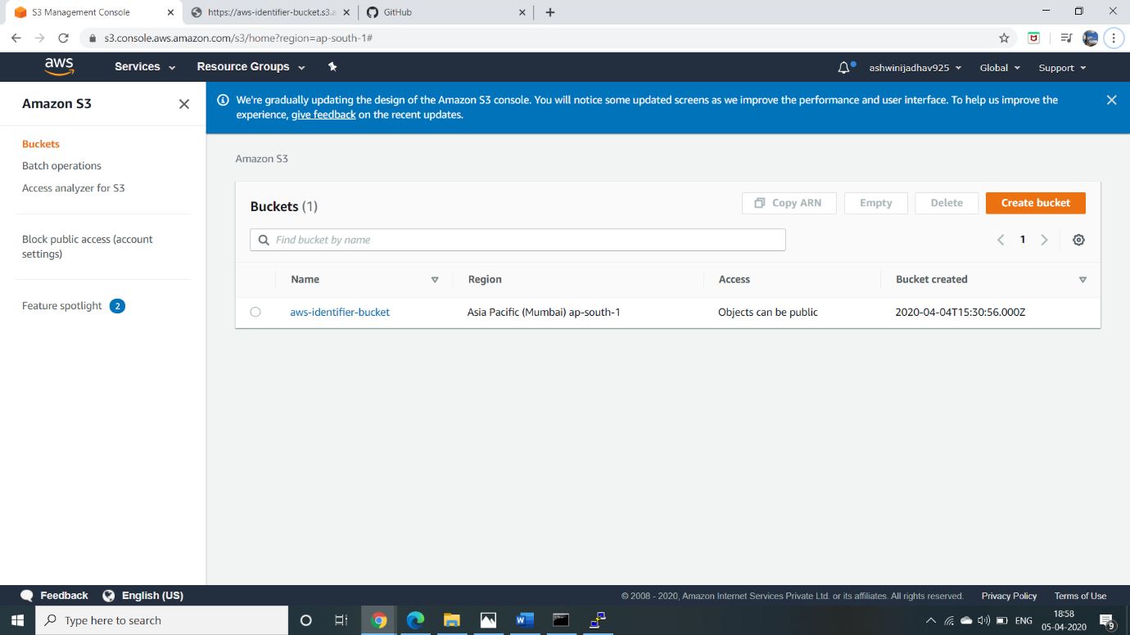

**4: Rekognition Dashboard**

